Room C Question 1
Pelvic Fracture with intraperitoneal bladder rupture.
Stem: A 32-year-old is on a motorcycle group ride when he crashes his motorcycle on the highway. He is helmeted. He is thrown approximately 30 feet. The patient is found unconscious by emergency medical services (EMS).
He is hypotensive with systolic blood pressure in the 80s. He responds to a 1 L normal saline (NS) fluid bolus by EMS, and systolic blood pressure is now 100 mm Hg.
Upon arrival to the trauma bay, he is awake but confused. He is tachycardic with heart rate in the 140s. Systolic blood pressure is back in the 80s. He is given 2 units of blood. He is complaining of lower abdominal pain and significant bilateral hip pain.

What would you like to do now?
- ATLS (ABCDE) (Airway, breathing, circulation, disability, exposure).
- Two wide bore 16-18 gauge IV cannulas. Obtain blood for labs (Type and screen / cross match, CBC, CMP, Coags, lactate).
On secondary Survey you see blood at the urethral meatus what would you check for also during you secondary survey?
-Check pelvic ring instability: How? applying gentle pressure from the lateral aspect of each iliac wing with both hands.
- Digital rectal exam.
- Chest and pelvic films.
- FAST.
The patient in the scenario undergoes a chest x-ray with no acute findings Pelvis x-ray shows:
Widening of the pubic symphysis. There is diastasis of the right sacroiliac (SI) joint.
- FAST was positive for fluid in the pelvis.

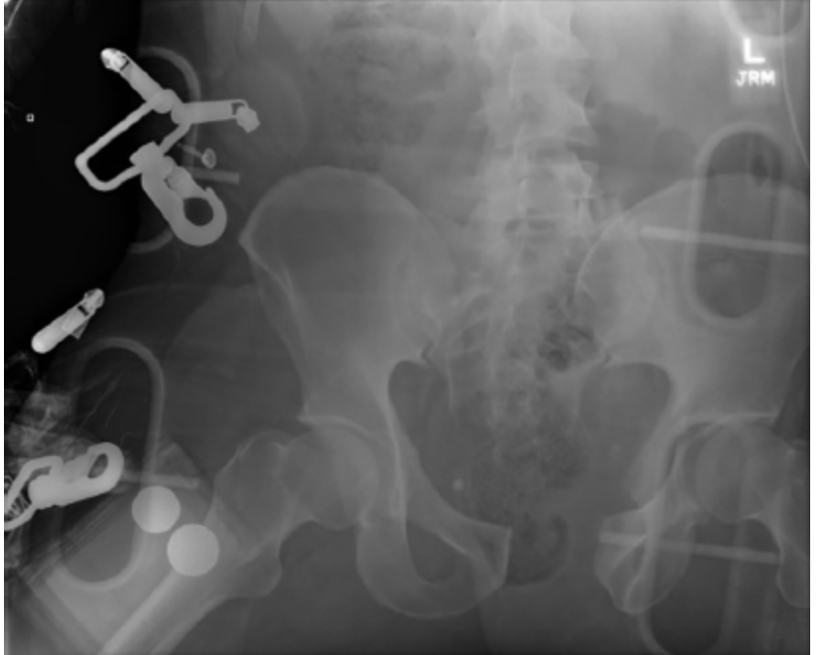
Now what? Pelvic binder
- The patient was resuscitated according to ATLS guidelines. He stabilized after transfusion of 2 units of blood in the trauma bay. A pelvic binder was placed. Now what? CT imaging.
- CT imaging.
  - A large volume of contrast-enhanced urine was identified within the peritoneum on delayed images. (To the examiner: consistent with urine extravasation and not contrast from pelvic vasculature)
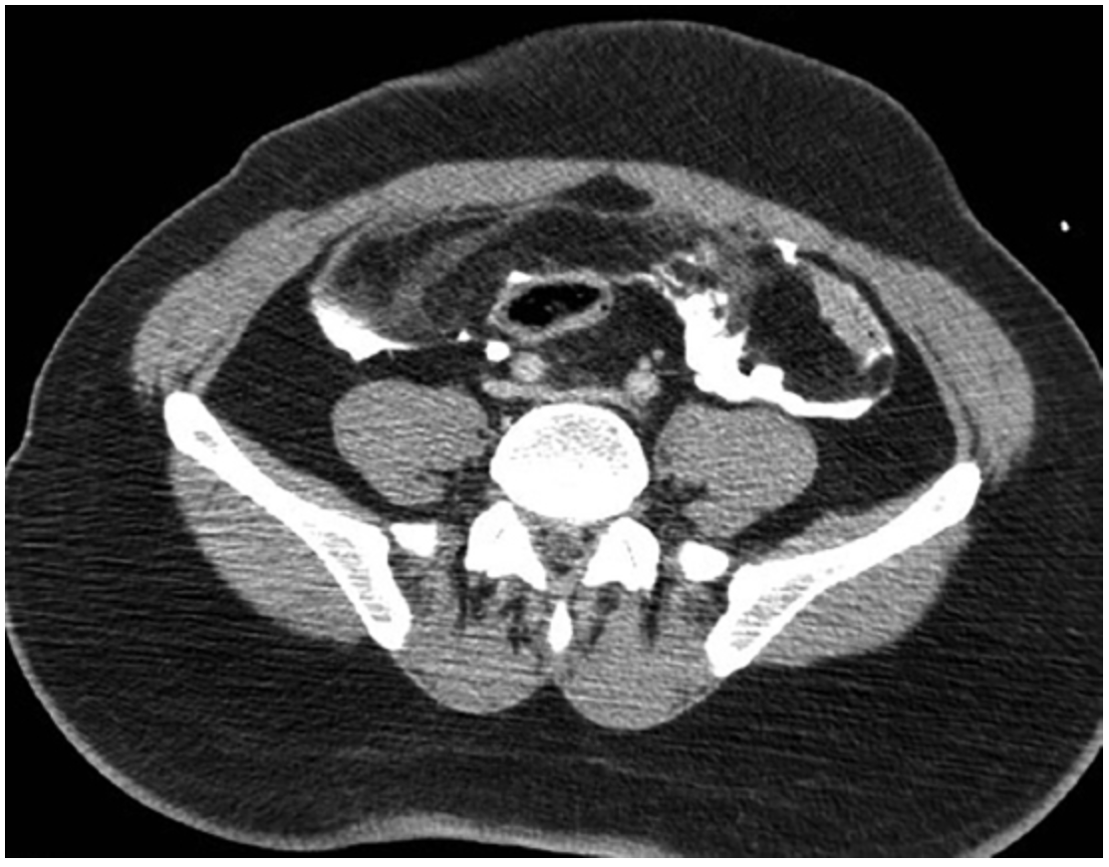
- An “open-book” pelvic fracture.
What is your diagnosis and what is your next step?
- Intraperitoneal bladder rupture and open book pelvic fracture.
- Ex. Lap: Limited incision as extending the incision below the semilunar line may lead to further hemorrhage by increasing anterior extension of a pelvic hematoma.
- Bladder repair. How?
  - Assess trigone and ureters.
  - Two layers.
  - Test repair by instilling 200 mL of normal saline into the bladder, clamp the foley and assess for leak.
  - Leave Foley.

Scenario: Same patient , patient was hemodynamically, stabilized with blood transfusion CT showed contrast extravasation in the pelvis. After CT patient became again hypotensive. You proceeded to the OR for ex.lap. Describe?
  - Ex. Lap: Limited incision, stay above the semilunar line. (Extending the incision below the semilunar line may lead to further hemorrhage by increasing anterior extension of pelvic hematoma) Tightly packing the pelvis intraperitoneal.
  - Preperitoneal packing with separate lower incision.
  - Temporary abdominal closure.
  - Postoperatively, the patient may need to be managed with angiography and embolization if there is continued hemorrhage.
  - Once stabilized, the patient can be returned to the operating room for re-exploration. Stabilization of the pelvis fracture, either internal or external, may be considered in conjunction with orthopedics.

Room 3 Question 2

Melanoma
Stem: A 40-year-old male presents with a pigmented lesion on his right lower extremity. First noticed it three months ago, denies recent changes in the appearance of the lesion. He uses sunscreen sporadically and recalls having sunburns as a teenager.
His medical and surgical history are unremarkable.
He denies a personal or family history of skin cancers.
Physical exam reveals pigmented skin lesion asymmetric with irregular borders and variegated pigmentation ranging from light brown to black, with scattered areas of red.

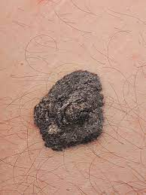

What is your differential diagnosis?
- Melanoma
- Melanocytic nevus
- Basal cell carcinoma
- Seborrhoeic keratosis
- Dermatofibroma

What would you like to do now?
- Complete skin exam evaluating for additional suspicious lesions, regional lymph node exam.
- Biopsy

Biopsy returns as melanoma, Breslow depth 1.2mm with no evidence of ulceration, mitotic rate < 1 mitosis/mm² (T2a)

What is Next?
Wide local excision and SLNB w/ margins of 1.0 to 2.0mm
Order immunohistochemistry for nodes (BRAF, S100)

Pathology returns as melanoma, Breslow depth 1.2mm, negative margins, 2 of 3 nodes positive for metastatic disease.
- Stage w/ PET CT
- Completion lymph node dissection VS active nodal surveillance w/ ultrasound.

You proceed CLND, describe?
Inguinal lymph node dissection:
- Mark Incision
- Dissect the subcutaneous until you reach superficial fascia (Campers fascia).
- Incise the fascia gently.
- Lift the fascia and dissect parallel to the lower border of the fascia to separate the superficial inguinal nodes from the subcutaneous tissue.
- Continue until you reach the inguinal ligament (upper border of the dissection).
- Dissect the superficial inguinal lymph nodes off the inguinal ligament starting from the upper edge of the ligament down to the femoral triangle.
- Dissect the lymph-nodes off the muscles.
- Separating the groin nodes off the femoral triangle floor proceeding from lateral to medial.
- Identify the great saphenous vein and dissect carefully until the point of insertion with the femoral vein.

- Adjuvant therapy options: nivolumab (programmed death 1 inhibitor)

- Or targeted therapy with combination of BRAF/MEK inhibitors;
(IFN alfa and ipilimumab have fallen out of favor)

- Follow up every 3-6 months for 2-3 years, then annually.

Can you give examples?!

Nivolumab (anti-PD-1 antibody), targeted therapy against BRAF (dabrafenib).

Room 3 Question 3
Burn (Reviewed by Dr. Newell)
Stem: A 47 y/o male is brought to the ED by EMS after being evacuated from a bedroom fire, started while he was smoking in his bed.
Upon evaluation he is awake and conversive but appears confused.
He is noted to have 60% TBSA burns to his upper torso, sparing only his lower extremities. His nasal hair is singed and he has a productive cough with a hoarse voice.
HR- 115, RR- 30, BP – 95/50, Temp – 37C, SpO2-100%.

Additional Workup or Studies:
CMP, CBC, carboxyhemoglobin, lactate

What are you concerned about?!:
- Airway compromise with an upper airway inhalation injury
- Development of decreased pulmonary compliance with circumferential burns to the torso
- Carbon monoxide poisoning
- Hypothermia
- ARDS/multisystem organ failure
- Compartment syndrome in extremities or abdomen

What would you like to do now?
- Intubate – 100% FiO2
- Serial carboxyhemoglobin levels
- Establish adequate IV access and initiate fluid resuscitation using

parkland formula:
2-4 ml/kg/%TBSA burn using LR. First ½ within 8 hours of burn.
Second ½ in the next 16 hours

- Place a foley to monitor resuscitation. Goal 30 – 50 cc/hr

Scenario: Patient has been transported to the ICU and is being mechanically ventilated. You get a call from respiratory therapy that his peak airway pressures have increased to 35. What are you concerned about?

- Abdominal compartment syndrome.
- Restrictive physiology due to thoracic eschars)

What would you do?
- check bladder pressure
- Perform escharotomy of thorax

Describe
- Escharotomy of the thorax
- Vertical incision bilaterally between mid-clavicular line and mid axillary line.
- Connected by transverse incision x 2
- Bronchoscopy to evaluate degree of inhalational injury for prognostication and treat potential mucus plugging

What is the ARDS/vent management?
- Low tidal volume (4-6 ml/kg)
- Peak pressures <30
- Permissive hypercapnia (ph >7.2)
- Increase PEEP
- Consider proning.

